Student Management API Operations

1. POST /students – Create Student
Performed the POST operation for student ID 100 and successfully created the student.
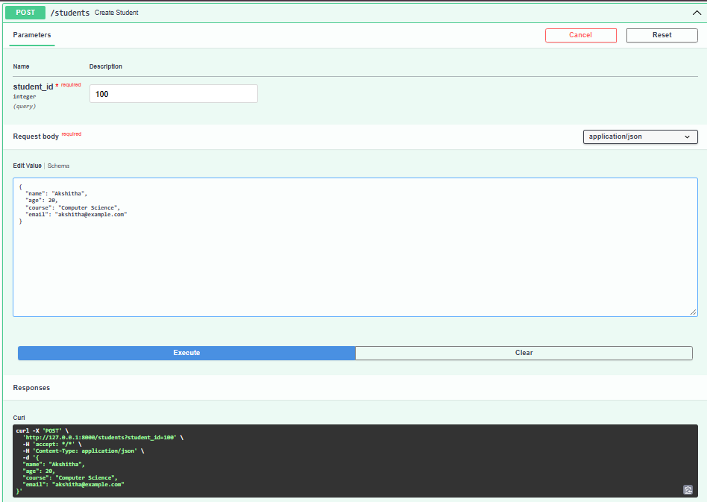
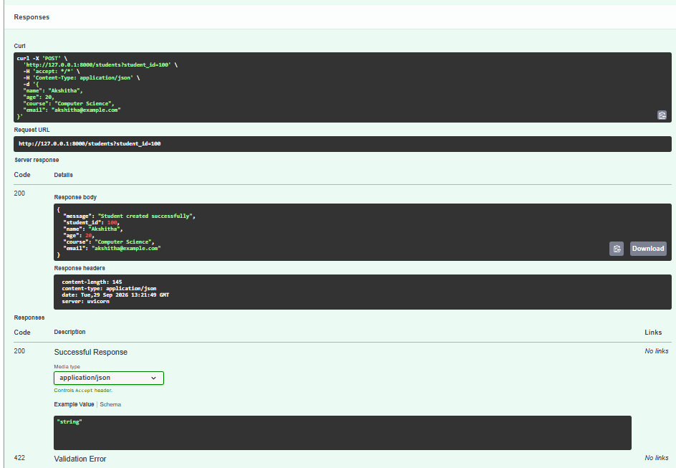
2. GET /students – Get Students
Performed the GET operation to retrieve the student records and displayed the details of student ID 100.

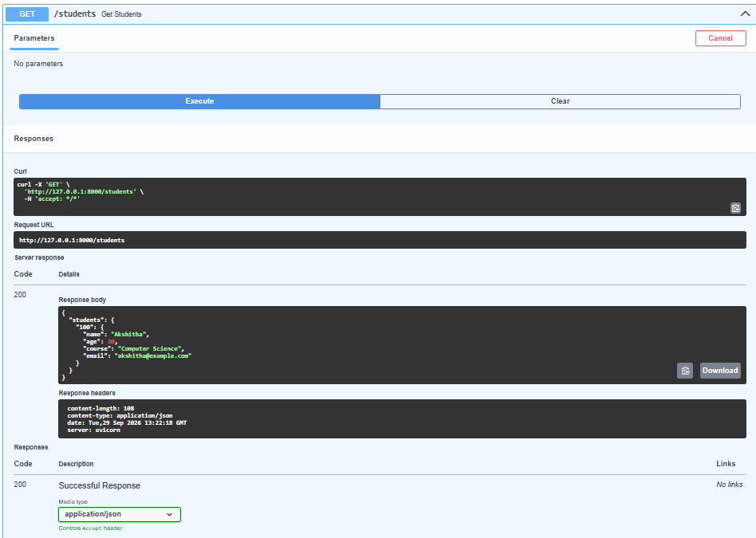
3. GET / – Home
Performed the GET operation on the home endpoint and successfully received the welcome message.
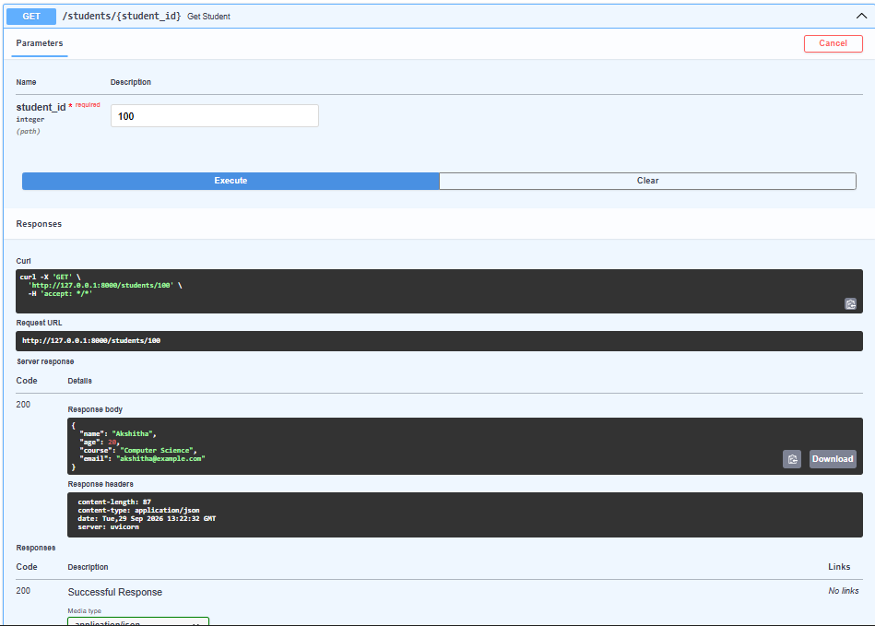
4. PUT /students/{student_id} – Update Student
Performed the PUT operation for student ID 100 and successfully updated all the student's details.

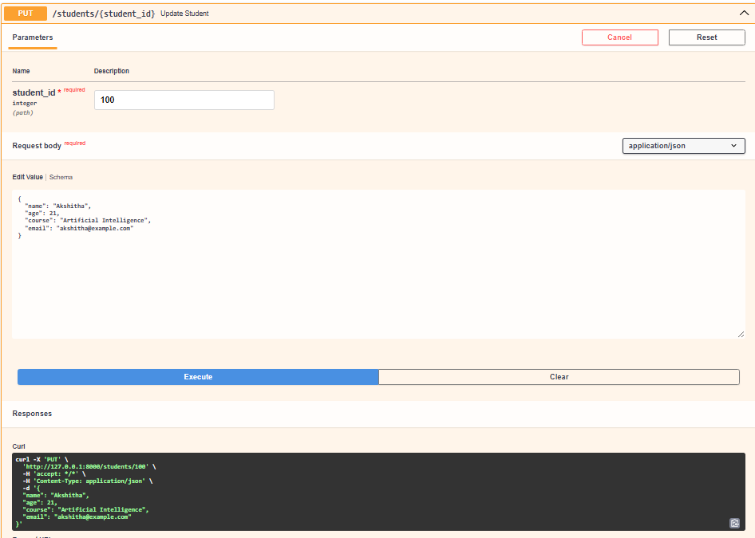
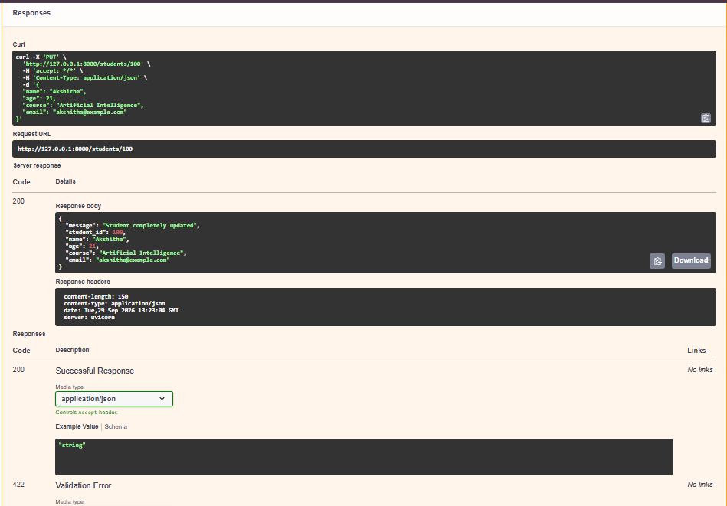

5. PATCH /students/{student_id} – Partial Update Student
Performed the PATCH operation for student ID 100 and successfully updated the course to Data Science
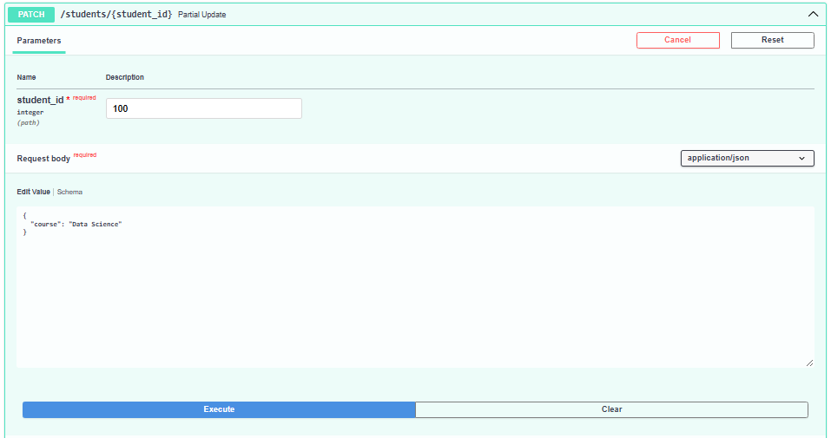
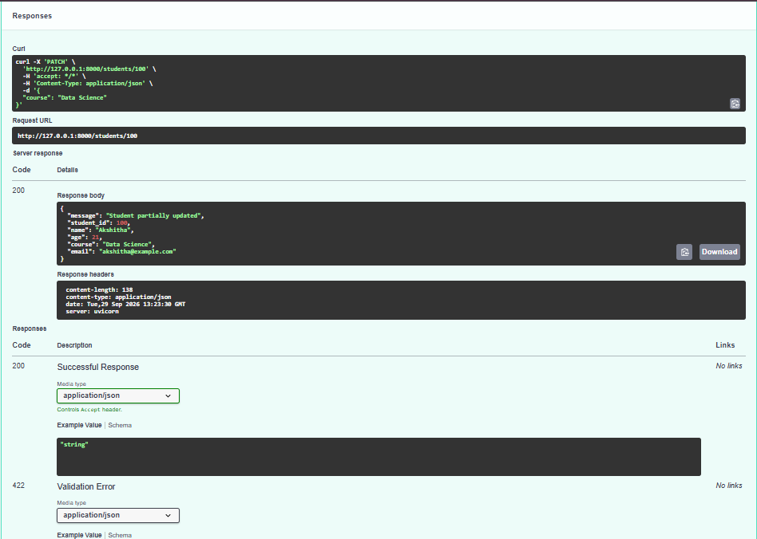
6. DELETE /students/{student_id} – Delete Student
Performed the DELETE operation for student ID 100 and successfully deleted the student record.
